Chapter 17 Projects

- [after §17.3] Changing Color and Alignment *:

Write a complete program named Buttons that implements a window with three buttons – left, blue, and reset. When the left button is clicked, the window’s contents (the three buttons) shifts left. When the blue button is clicked, the window’s background color changes to blue. When the reset button is clicked, the window’s contents shifts back to the original center alignment and the window’s background color changes back to its original color.

In implementing the reset functionality, don’t try to figure out a color constant that’s used for the window’s original color value. That’s counterproductive because the color might be different on different computers. Instead, retrieve and save the window’s original color and then when the color needs to be reset, use that saved original color value.

Sample session (read the windows left to right):

Original display: After the Left button is clicked:

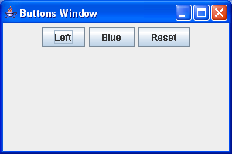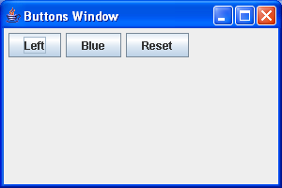

After the Blue button is clicked: After the Reset button is clicked:

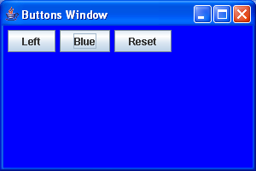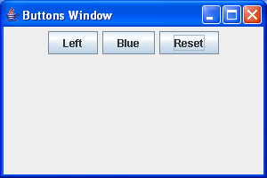

- [after §17.6] Click Tracker *:

- Basic capability:

Write a complete program that monitors a user’s clicks on a grid of nine buttons. When a button is clicked, change its label to "Clicked!"

Sample session (read the windows left to right):

Initial display: After clicking on button #4:

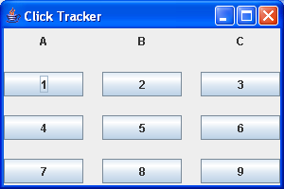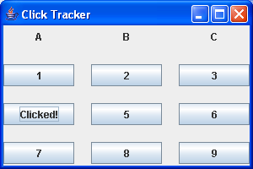

After clicking on button #8:

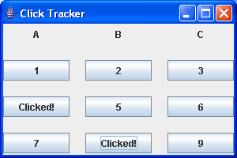

Note:
- Your program should contain a class named ClickTracker.
- Use a GridLayout manager scheme.
- To promote scalability (i.e., to allow for future growth), use a loop to generate the A, B, and C labels and use another loop to generate the nine buttons.
- Use an inner class for the listener.

As always:
- Limit your use of class variables and instance variables – only use them if appropriate.
- Use appropriate modifiers for your methods. The modifiers we’ve discussed are private, public, protected, static, and final.
- Use helping methods if appropriate.
- Mimic the sample session precisely. In particular, note the window’s title, the window’s size, and the positions of components.

- Enhancement:

Improve the look of your program by enhancing the button borders. Initially, set the buttons’ borders to BevelBorder.RAISED. When a button is clicked, set its border to BevelBorder.LOWERED. To set a button’s border, call setBorder and pass in an instantiated BevelBorder object. For details, see Sun’s API documentation.

Sample session:

Initial display: After clicking button #3:

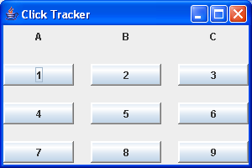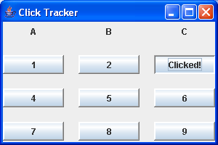

- Further enhancement:

Add functionality to your click-tracker program so that when a button is clicked a second time, a warning dialog box appears. Hint: In your actionPerformed method, use the ActionEvent parameter’s getActionCommand method.

Sample session:

After clicking a button a second time:

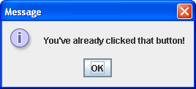

- [after §17.7] Tic-Tac-Toe Game **:

Implement a tic-tac-toe game. Use the simple TicTacToe program in Section 17.6 as a starting point. As described in Section 17.7, add the following functionality to the simple TicTacToe program:
- Check for a win. If there’s a winner, display a dialog box with X wins! or O wins!
- Check for a cat’s game. If there’s a cat’s game, display a dialog box with Cat's game!
- If there’s a win or a cat’s game, prepare for a new game.

- [after §17.10] Word Order Game, revisited **:

This is an enhanced version of a project presented in Chapter 16. In this project, you’ll use embedded layout managers. Create a simple computer game that provides kids with word-ordering practice. Your program should display a list of words and two text boxes. The user types two of the words into the two text boxes and then presses a Submit button. The program makes sure that the words come from the word list and are in correct dictionary order. Here is what the display should look like after the user enters the words cat and dog:

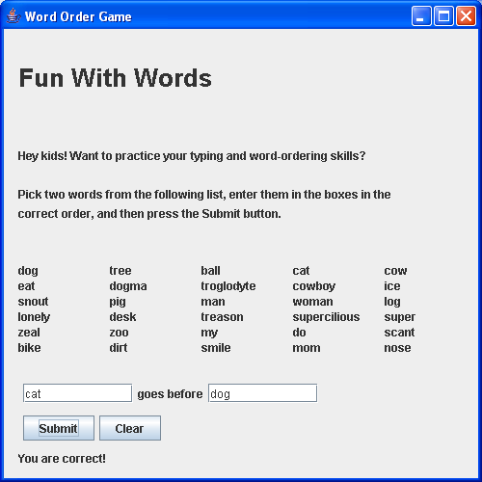

If the user now clicks the Clear button, the two words in the text boxes should disappear, and the user should be able to repeat the exercise. Notice the "You are correct!" message on the last row. Initially, there should be nothing in this location. When the user clicks the Submit button, one of the following messages should appear where the "You are correct!" is shown:

- If there is nothing in either of the two text boxes, print:
Enter words in both boxes.
- If neither of the two entered words is in the list, print:
Neither entry is in the word list.
- If the first word is not in the list, print:
First entry not in word list – check spelling.
- If the second word is not in the list, print:
Second entry not in word list – check spelling.
- If both words are from the list but are the same, print:
You entered the same words. Try again.
- If both words are from the list but are in the wrong order, print:
Wrong. Try again.

If the user enters two words from the word list, your program should call the String class’s compareTo method to determine whether the words are in correct dictionary order.

For the overall window, use a BorderLayout, and in the WEST region put a JLabel with 5 spaces. This will provide a uniform space on the left side of the display. In the CENTER region, put a JPanel called mainPanel, and use a one-column GridLayout for it. This panel should hold all of the other GUI components:

- Put a JLabel called heading in the first row, and use the following setFont method call to make the heading larger than normal:
heading.setFont(heading.getFont().deriveFont(26f));
- Put another panel with a one-column GridLayout in the second row, and put instruction labels, with appropriate lines, in this panel.
- Put another panel with a five-column GridLayout in the third row, and put thirty labels with the 30 words in this panel.
- Put another panel with a three-row GridLayout in the fourth row. In this panel, put the first text box, the "goes before" label, the second text box, the two buttons, and the response label.

Do not use the setPreferredSize method in this implementation.

- [after §17.10] Thermal Diffusion in a Ground-Source Heat Pump’s Well ***:

Write a program that calculates temperatures in the earth around a ground-source heat-pump well, over the course of one year.

As an instance variable, declare a 42 element double[] pointTemp array to hold the instantaneous temperature in the earth at different distances (3", 7", 11", 15", 19", etc., on a 4" spacing) from the center of the well.

In the main method, declare a local double time variable for the hour and a local double[] avgPointTemp array for average temperature at the 42 points over a 6-day time period. Then:

Instantiate an object of the class you are defining.

Loop through 60 time periods. In each time period do the following:

Initialize all 42 average temperatures to zero.

Loop through 144 hours (6 days), and for each hour, do the following:

Increment the time by one hour.

Call a load method to compute heatFlow = BTU/Hr going into the well at the current hour.

Call a diffuse method with the just-computed heatFlow as an argument to compute the values for the elements in the pointTemp array.

Accumulate computedTemperature / 144 in the each element of the average temperature array, so that after 144 hours this array has the average temperature at all points for the 6-day time period ending at the current hour.

Call a display method to display the results for the current time period.

  - Implement a constructor, a load method, a diffuse method, and a display method to display the computed results in a tabular fashion in the Command Prompt window.

Have the constructor initialize all temperatures in the pointTemp array to 58 degrees F.

Implement the load method, using this algorithm to calculate the net heat flow into the ground in each hourly period:

First compute the heat flow into the building due to weather, internal electrical usage, and people heat, using this formula:
heatFlow = -4000 – 28,000 * cos(2π * hour / (360 * 24))
+ 8,000 * cos(2π * hour / (10 * 24)) + 12,000 * sin(2π * (hour – 10) / 24 );
The constant represents net annual average space cooling. (On average, the space needs a small amount of heat.) The three sinusoidal terms correspond to annual variation, a typical 10-day weather cycle, and daily variation.)

Then add fan-motor heat with this formula:
heatFlow += 0.04 * Math.abs(heatFlow);

Then subtract heat recovered to heat domestic hot water with this formula:
heatFlow += -1000;

Then, if net heatFlow is less then -38,000, set it equal to -38,000.

Then, add compressor-motor heat with this formula:
heatFlow += 0.18 * Math.abs(heatFlow);

Finally add groundwater-pump-motor heat with this formula:
heatFlow += 0.04 * Math.abs(heatFlow);

Implement the diffuse method with a single parameter, heatFlow, to update the temperature profile in the ground at hourly intervals. Use these constants:

double depth = 900.0; // feet
double conductivity = 0.83; // BTU/Hr/ft/degF
double density = 140; // lb/cuft
double specificHeat = 0.19; // BTU/lb/degF
double diffusion =
conductivity / (density * specificHeat); // sqft/hour
double wellRadius = 0.25; // ft
double deltaX = 0.33; // ft
double factor = diffusion * deltaT / (deltaX * deltaX);

Model the radial diffusion process like this:

First, use heatFlow to establish the new well temperature (pointTemp[0]) in terms of the previous temperature at the next point and the above constants, using this formula:

pointTemp[0] = pointTemp[1] + heatFlow /
(2π * depth * conductivity * log_{e}(1 + deltaX / wellRadius)).

Then, for points 1 through 40, use the following formula to calculate the new temperature at each successive point in terms of previous temperatures at that point and the points before and after it:

pointTemp[j] = pointTemp[j] + factor *
((1 - 0.5/j) * pointTemp[j-1]- 2.0 * pointTemp[j] +
(1 + 0.5 /j) * pointTemp[j+1])

However, immediately before updating point 40, set the value at point 41 equal to the previous value at point 40. This establishes a plausible outside boundary condition.

Implement the display method. It should receive inputs for three parameters, periodLength, periodNumber, and a reference to main’s avgPointTemp array, and it should print this result:

Output:

time= 144 46 52 54 55 56 56 57 57 57 57 58 58 58 58 58 58 58 58 58 58 58
58 58 58 58 58 58 58 58 58 58 58 58 58 58 58 58 58 58 58 58 58
time= 288 45 50 52 53 54 55 55 56 56 56 57 57 57 57 57 57 57 58 58 58 58
58 58 58 58 58 58 58 58 58 58 58 58 58 58 58 58 58 58 58 58 58
time= 432 43 49 51 53 53 54 55 55 55 56 56 56 56 57 57 57 57 57 57 57 57
57 58 58 58 58 58 58 58 58 58 58 58 58 58 58 58 58 58 58 58 58
time= 576 44 50 51 52 53 54 54 55 55 55 56 56 56 56 56 57 57 57 57 57 57
57 57 57 57 57 58 58 58 58 58 58 58 58 58 58 58 58 58 58 58 58
time= 720 43 49 51 52 53 53 54 54 55 55 55 56 56 56 56 56 56 57 57 57 57
57 57 57 57 57 57 57 57 57 58 58 58 58 58 58 58 58 58 58 58 58
time= 864 44 49 51 52 53 53 54 54 55 55 55 55 56 56 56 56 56 56 56 57 57
57 57 57 57 57 57 57 57 57 57 57 57 57 57 57 57 57 58 58 58 58
time= 1008 45 50 51 52 53 53 54 54 54 55 55 55 55 56 56 56 56 56 56 56 56
57 57 57 57 57 57 57 57 57 57 57 57 57 57 57 57 57 57 57 57 57
time= 1152 43 49 51 52 53 53 54 54 54 55 55 55 55 55 56 56 56 56 56 56 56
56 56 57 57 57 57 57 57 57 57 57 57 57 57 57 57 57 57 57 57 57
time= 1296 47 50 52 52 53 53 54 54 54 55 55 55 55 55 55 56 56 56 56 56 56
56 56 56 56 57 57 57 57 57 57 57 57 57 57 57 57 57 57 57 57 57
time= 1440 46 50 51 52 53 53 54 54 54 54 55 55 55 55 55 55 56 56 56 56 56
56 56 56 56 56 56 56 57 57 57 57 57 57 57 57 57 57 57 57 57 57
time= 1584 47 51 52 53 53 54 54 54 54 55 55 55 55 55 55 55 56 56 56 56 56
56 56 56 56 56 56 56 56 56 56 56 57 57 57 57 57 57 57 57 57 57
time= 1728 49 52 52 53 53 54 54 54 54 55 55 55 55 55 55 55 55 56 56 56 56
56 56 56 56 56 56 56 56 56 56 56 56 56 56 56 56 56 56 56 56 56
time= 1872 48 51 52 53 54 54 54 54 55 55 55 55 55 55 55 55 55 56 56 56 56
56 56 56 56 56 56 56 56 56 56 56 56 56 56 56 56 56 56 56 56 56
time= 2016 53 54 54 54 54 54 54 55 55 55 55 55 55 55 55 55 55 55 56 56 56
56 56 56 56 56 56 56 56 56 56 56 56 56 56 56 56 56 56 56 56 56
time= 2160 52 53 54 54 54 54 55 55 55 55 55 55 55 55 55 55 55 56 56 56 56
56 56 56 56 56 56 56 56 56 56 56 56 56 56 56 56 56 56 56 56 56
time= 2304 54 55 55 55 55 55 55 55 55 55 55 55 55 55 55 55 56 56 56 56 56
56 56 56 56 56 56 56 56 56 56 56 56 56 56 56 56 56 56 56 56 56
time= 2448 57 56 56 56 55 55 55 55 55 55 55 55 55 55 56 56 56 56 56 56 56
56 56 56 56 56 56 56 56 56 56 56 56 56 56 56 56 56 56 56 56 56
time= 2592 56 56 56 56 56 56 56 56 56 56 56 56 56 56 56 56 56 56 56 56 56
56 56 56 56 56 56 56 56 56 56 56 56 56 56 56 56 56 56 56 56 56
time= 2736 62 59 58 57 57 57 56 56 56 56 56 56 56 56 56 56 56 56 56 56 56
56 56 56 56 56 56 56 56 56 56 56 56 56 56 56 56 56 56 56 56 56
time= 2880 61 58 58 57 57 57 57 57 56 56 56 56 56 56 56 56 56 56 56 56 56
56 56 56 56 56 56 56 56 56 56 56 56 56 56 56 56 56 56 56 56 56
time= 3024 63 60 59 59 58 58 58 57 57 57 57 57 57 56 56 56 56 56 56 56 56
56 56 56 56 56 56 56 56 56 56 56 56 56 56 56 56 56 56 56 56 56
time= 3168 67 62 60 59 59 58 58 58 57 57 57 57 57 57 57 57 56 56 56 56 56
56 56 56 56 56 56 56 56 56 56 56 56 56 56 56 56 56 56 56 56 56
time= 3312 65 62 61 60 59 59 59 58 58 58 58 57 57 57 57 57 57 57 57 56 56
56 56 56 56 56 56 56 56 56 56 56 56 56 56 56 56 56 56 56 56 56
time= 3456 71 65 63 61 61 60 59 59 59 58 58 58 58 57 57 57 57 57 57 57 57
57 56 56 56 56 56 56 56 56 56 56 56 56 56 56 56 56 56 56 56 56
time= 3600 70 64 62 61 60 60 59 59 59 59 58 58 58 58 58 57 57 57 57 57 57
57 57 57 57 57 56 56 56 56 56 56 56 56 56 56 56 56 56 56 56 56
time= 3744 72 66 64 63 62 61 60 60 60 59 59 59 58 58 58 58 58 57 57 57 57
57 57 57 57 57 57 57 57 57 56 56 56 56 56 56 56 56 56 56 56 56
time= 3888 75 67 65 63 62 61 61 60 60 59 59 59 59 58 58 58 58 58 58 57 57
57 57 57 57 57 57 57 57 57 57 57 57 57 57 57 57 56 56 56 56 56
time= 4032 72 66 65 63 62 62 61 61 60 60 60 59 59 59 59 58 58 58 58 58 58
58 57 57 57 57 57 57 57 57 57 57 57 57 57 57 57 57 57 57 57 57
time= 4176 77 69 66 65 63 63 62 61 61 60 60 60 59 59 59 59 58 58 58 58 58
58 58 58 57 57 57 57 57 57 57 57 57 57 57 57 57 57 57 57 57 57
time= 4320 75 68 66 64 63 62 62 61 61 61 60 60 60 59 59 59 59 59 58 58 58
58 58 58 58 58 58 58 57 57 57 57 57 57 57 57 57 57 57 57 57 57
time= 4464 76 69 67 65 64 63 63 62 62 61 61 60 60 60 60 59 59 59 59 59 58
58 58 58 58 58 58 58 58 58 58 58 57 57 57 57 57 57 57 57 57 57
time= 4608 78 70 67 65 64 63 63 62 62 61 61 61 60 60 60 60 59 59 59 59 59
59 58 58 58 58 58 58 58 58 58 58 58 58 58 58 58 58 58 58 58 58
time= 4752 74 68 66 65 64 63 63 62 62 62 61 61 61 60 60 60 60 59 59 59 59
59 59 59 59 58 58 58 58 58 58 58 58 58 58 58 58 58 58 58 58 58
time= 4896 78 70 68 66 65 64 63 63 62 62 61 61 61 61 60 60 60 60 60 59 59
59 59 59 59 59 59 59 58 58 58 58 58 58 58 58 58 58 58 58 58 58
time= 5040 74 68 66 65 64 64 63 63 62 62 61 61 61 61 60 60 60 60 60 60 59
59 59 59 59 59 59 59 59 59 59 59 58 58 58 58 58 58 58 58 58 58
time= 5184 74 69 67 66 65 64 63 63 62 62 62 61 61 61 61 60 60 60 60 60 60
60 59 59 59 59 59 59 59 59 59 59 59 59 59 59 59 59 59 59 59 59
time= 5328 75 68 66 65 64 64 63 63 62 62 62 61 61 61 61 61 60 60 60 60 60
60 60 60 59 59 59 59 59 59 59 59 59 59 59 59 59 59 59 59 59 59
time= 5472 70 66 65 64 64 63 63 63 62 62 62 62 61 61 61 61 61 60 60 60 60
60 60 60 60 60 60 59 59 59 59 59 59 59 59 59 59 59 59 59 59 59
time= 5616 73 68 66 65 64 63 63 63 62 62 62 62 61 61 61 61 61 61 60 60 60
60 60 60 60 60 60 60 60 60 59 59 59 59 59 59 59 59 59 59 59 59
time= 5760 68 65 64 63 63 63 62 62 62 62 62 61 61 61 61 61 61 61 61 60 60
60 60 60 60 60 60 60 60 60 60 60 60 60 60 60 59 59 59 59 59 59
time= 5904 67 65 64 64 63 63 62 62 62 62 62 61 61 61 61 61 61 61 61 60 60
60 60 60 60 60 60 60 60 60 60 60 60 60 60 60 60 60 60 60 60 60
time= 6048 67 64 63 63 62 62 62 62 62 61 61 61 61 61 61 61 61 61 61 61 60
60 60 60 60 60 60 60 60 60 60 60 60 60 60 60 60 60 60 60 60 60
time= 6192 62 62 62 62 62 62 62 61 61 61 61 61 61 61 61 61 61 61 61 61 60
60 60 60 60 60 60 60 60 60 60 60 60 60 60 60 60 60 60 60 60 60
time= 6336 64 62 62 62 62 61 61 61 61 61 61 61 61 61 61 61 61 61 61 61 60
60 60 60 60 60 60 60 60 60 60 60 60 60 60 60 60 60 60 60 60 60
time= 6480 59 60 60 60 60 61 61 61 61 61 61 61 61 61 61 61 61 61 60 60 60
60 60 60 60 60 60 60 60 60 60 60 60 60 60 60 60 60 60 60 60 60
time= 6624 58 60 60 60 60 60 60 60 60 60 60 60 60 60 60 60 60 60 60 60 60
60 60 60 60 60 60 60 60 60 60 60 60 60 60 60 60 60 60 60 60 60
time= 6768 58 59 59 59 60 60 60 60 60 60 60 60 60 60 60 60 60 60 60 60 60
60 60 60 60 60 60 60 60 60 60 60 60 60 60 60 60 60 60 60 60 60
time= 6912 54 57 58 58 59 59 59 60 60 60 60 60 60 60 60 60 60 60 60 60 60
60 60 60 60 60 60 60 60 60 60 60 60 60 60 60 60 60 60 60 60 60
time= 7056 55 57 58 58 59 59 59 59 59 59 60 60 60 60 60 60 60 60 60 60 60
60 60 60 60 60 60 60 60 60 60 60 60 60 60 60 60 60 60 60 60 60
time= 7200 52 55 56 57 58 58 58 59 59 59 59 59 59 60 60 60 60 60 60 60 60
60 60 60 60 60 60 60 60 60 60 60 60 60 60 60 60 60 60 60 60 60
time= 7344 51 55 56 57 57 58 58 58 59 59 59 59 59 59 59 59 60 60 60 60 60
60 60 60 60 60 60 60 60 60 60 60 60 60 60 60 60 60 60 60 60 60
time= 7488 50 54 55 56 57 57 58 58 58 58 59 59 59 59 59 59 59 59 59 60 60
60 60 60 60 60 60 60 60 60 60 60 60 60 60 60 60 60 60 60 60 60
time= 7632 47 53 54 55 56 57 57 57 58 58 58 58 59 59 59 59 59 59 59 59 59
60 60 60 60 60 60 60 60 60 60 60 60 60 60 60 60 60 60 60 60 60
time= 7776 48 53 54 55 56 56 57 57 57 58 58 58 58 58 59 59 59 59 59 59 59
59 59 59 59 60 60 60 60 60 60 60 60 60 60 60 60 60 60 60 60 60
time= 7920 46 51 53 54 55 56 56 57 57 57 58 58 58 58 58 58 59 59 59 59 59
59 59 59 59 59 59 59 60 60 60 60 60 60 60 60 60 60 60 60 60 60
time= 8064 46 51 53 54 55 56 56 56 57 57 57 58 58 58 58 58 58 59 59 59 59
59 59 59 59 59 59 59 59 59 59 59 59 60 60 60 60 60 60 60 60 60
time= 8208 46 51 53 54 55 55 56 56 56 57 57 57 57 58 58 58 58 58 58 59 59
59 59 59 59 59 59 59 59 59 59 59 59 59 59 59 59 59 59 59 59 59
time= 8352 43 50 52 53 54 55 55 56 56 56 57 57 57 57 58 58 58 58 58 58 58
58 59 59 59 59 59 59 59 59 59 59 59 59 59 59 59 59 59 59 59 59
time= 8496 45 50 52 53 54 55 55 56 56 56 56 57 57 57 57 58 58 58 58 58 58
58 58 58 59 59 59 59 59 59 59 59 59 59 59 59 59 59 59 59 59 59
time= 8640 43 49 51 53 53 54 55 55 56 56 56 56 57 57 57 57 57 58 58 58 58
58 58 58 58 58 58 59 59 59 59 59 59 59 59 59 59 59 59 59 59 59

Each time is cumulative hours from the beginning of the standard year. There is one line of (wrapped around) data for each period of 144 hours or six days. The row of integers that follows each time is a profile of the average Fahrenheit temperature in the earth around the well during the period ending at the indicated time. The 42 temperatures printed for each time interval are ordered by distance from the center of the well, with the first point at the well surface and the last point almost 14 ft from the well.

  - Enhance the program written in part a) to make it dislay the output in GUI format.

Make the class extend JFrame.

Modify the constructor to provide a title and set the size for a 800 x 700 display window, that will look like this:

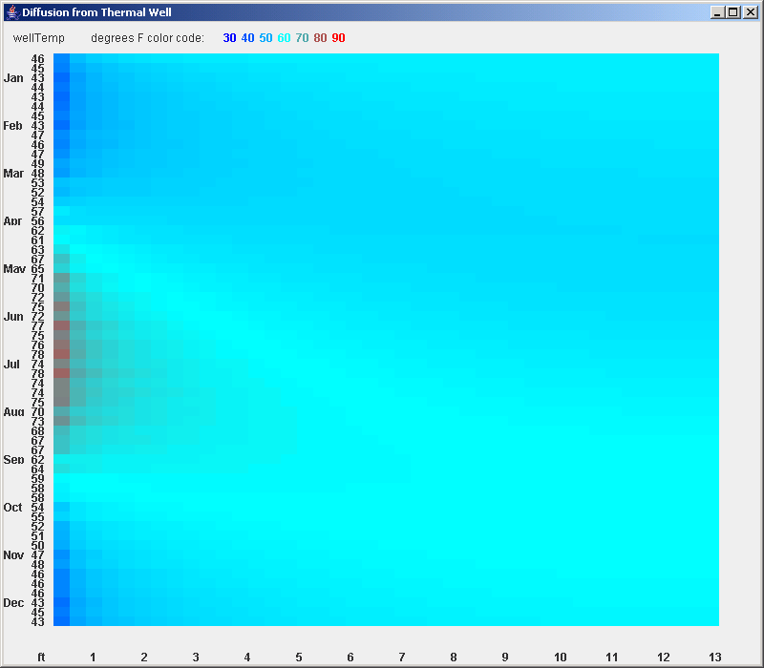

Call a createContents method to configure the display like this:

Use an overall BorderLayout scheme.

In BorderLayout.NORTH, insert a JPanel using FlowLayout.LEFT that includes a Label with the indicated text followed by the 7 JLabels for the 7 temperature numbers.
Use a call to a helper method called color to set the (foreground) coloring for each number to match its temperature value.

In BorderLayout.WEST, insert a JPanel using GridLayout(0,2). Use a loop to insert JLabels for month abbreviations in the first column and elements of a 60-element wellTemp array in the second column.

In BorderLayout.CENTER, insert a JPanel using GridLayout(0,42). Then using nested for loops, fill that JPanel with a 60 x 42 array of JPanel elements.

In BorderLayout.SOUTH, insert a JPanel using GridLayout(0,44). Then to that JPanel add little JLabels that insert the “ft” notation and appropriate numbers at appropriate places along the bottom of the display.

Implement a color method that translates a temperature number into a color. Use the following algorithm:
red = (degF – 60) / 30
green = 1.0 – abs(degF – 60) / 30
blue = (90 – degF) / 30
Whenever any of these three formulas produces a value greater than 1.0, set it equal to 1.0, and whenever it produces a number less than 0.0, set it equal to 0.0. This algorithm should produce a color range that progresses fairly uniformly from pure blue at 30 ºF, through green at 60 ºF, to pure red at 90 ºF.

Create a different display method that has only two parameters, periodNum and a reference to main’s avgPointTemp array. Make this method display the results as GUI rather than Command Prompt text. Provide the appropriate number for the vertical temperature label on the left side of the display by using JLabel’s setText method to copy the current value from pointTemp[0]. In a for loop that steps through points 0─41, use JPanel’s setBackgroundColor method to translate each pointTemp value to an appropriate color for each point in the profile (a small rectangular area in the CENTER part of the display) for the current time interval.

