Put Product Name Here

Put a representative screenshot or a UI sketch of your product here ↓
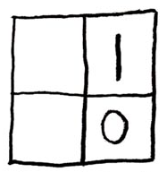
Supervisor: tutor name
  David Lim |   Liu Liu | [team member photo]  [team member name] | [team member photo]  [team member name]

Use real and recent photos that show the face clearly.
Remove all highlighted text before submission.
Do not remove items specified in this template (i.e. cover page contents should be in the first page and limited to one page only, page header should appear in every page). They are there for a reason.
In the interest of saving printer ink, use a plain white background for pages. You may change other formatting e.g. heading style, text font etc.
Convert to pdf before submission.

Acknowledgements

About Us
Similar to the AboutUs.md

User Guide

Developer Guide

Appendix A: …

Appendix B: …

